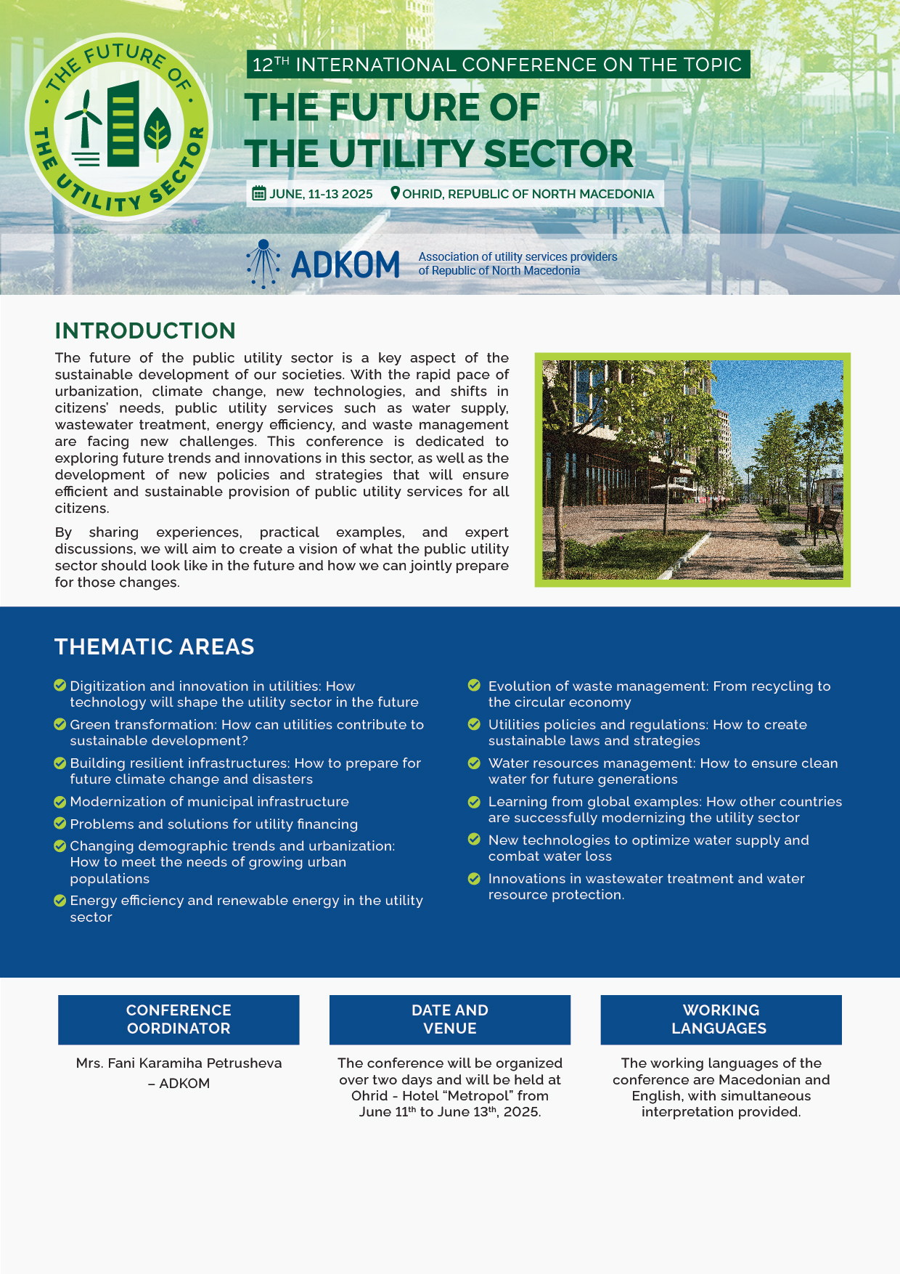

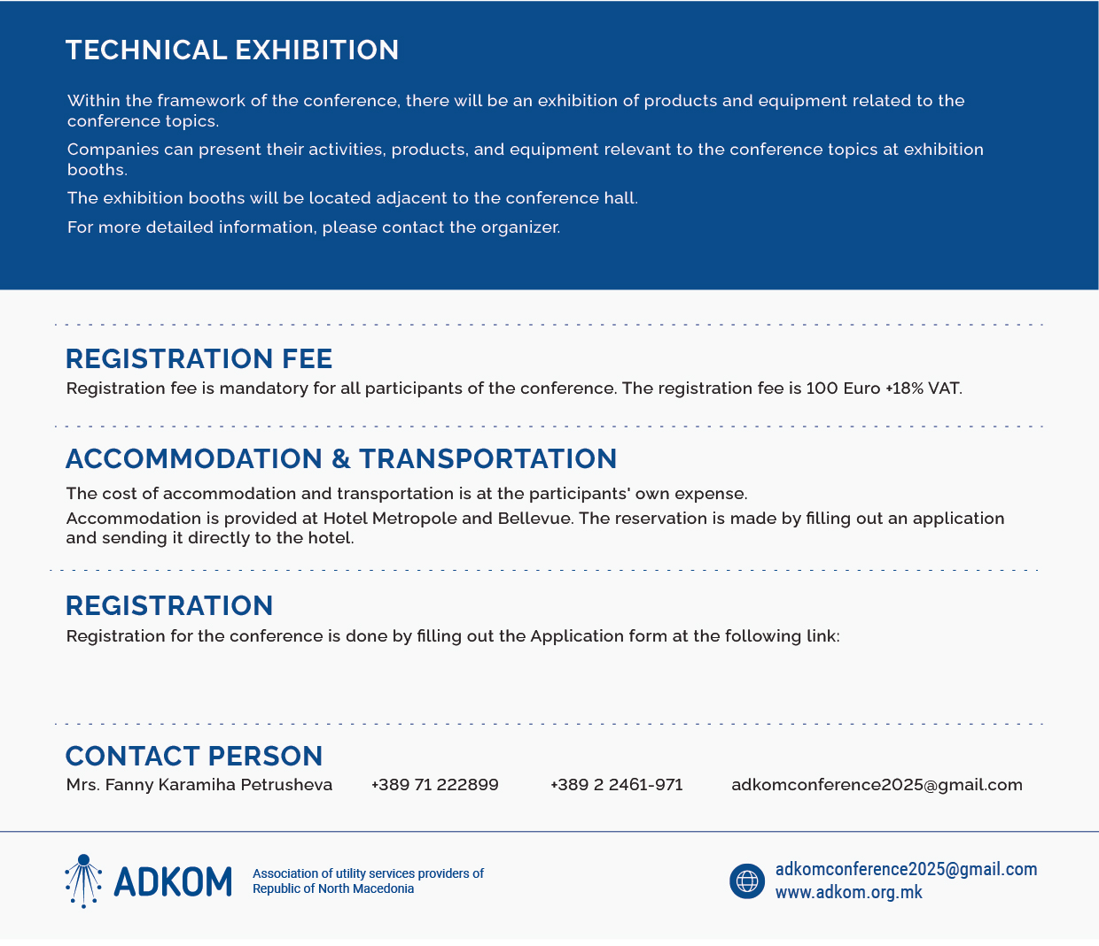

https://docs.google.com/forms/d/e/1FAIpQLSdVJkyN7Me40tTXgx_P-Ps7V4Tdh8HoCl-nWia-lWX4-aNEEQ/viewform?usp=pp_url

